The Southern African Institute of Forestry

Handbook order form

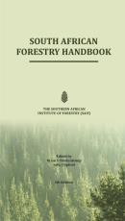The Southern African Institute of Forestry publishes three industry specific handbooks. I would like to order:

South African Forestry Handbook
Price: SAIF members: R400
Non members: R500

Fire Manager's Handbook on Veld and Forest Fires
Price: SAIF members: R300
Non members: R400

There’s Honey in the Forest
Price: SAIF members: R100
Non members: R150

International orders must contact the Secretariat for a quote due to currency and postage fluctuations.

A bulk discount of 10% applies on orders of 10 or more copies. Price includes VAT.

An extra R50 per book will be charged if we need to courier the book to you.

I am ◻ a member ◻ non-member of the SAIF.

Name
Company
Postal address
Contact number
Email address

Bank details: Nedbank Branch code: 169745 Account: 1697009913 Account name: SAIF
Email proof of payment to: saif@mweb.co.za.

